DL Auto-segmentation Options

# DL Auto-segmentation Advantages

* Faster than atlas- or model-based
* More accurate than atlas- or model-based
* Unlike atlas-based, we don’t have to train our own models

# MIM

Contour ProtégéAI includes over 3,000 datasets in its models. We send from sim to MIM, which matches image modality and/or DICOM SeriesDescription attribute to determine what DL model, if any, to apply. Unlike with Mobius3D, if the match is incorrect, it’s easy to change the DICOM data in MIM so that it is. If a DL model is to be applied, the dataset is sent to MIMcloud, OARs are segmented, and the results are sent back down to MIM, all in around five to seven minutes, depending on the amount of traffic on MIMcloud.

## Quotes

Frank is preparing quotes for four options:

1. Support and maintenance renewal only for our two licenses. This includes ProtégéAI for free until the three-year term is up.
2. Support and maintenance renewal plus a third license. This includes ProtégéAI for free since the number of licenses is the same as the number of treatment rooms used with MIM.
3. Support and maintenance renewal plus ProtégéAI. This is for our two licenses plus $10,000 per treatment room.
4. MIM Maestro Departmental Solutions (MDS). This is least expensive with a five-year upfront payment. (For the other three options, three-year upfront is least expensive; five-year is only less expensive than three-year if we pay annually.) MDS is unlimited licenses plus MIM Assistant and ProtégéAI. The other options only include MIM Assistant for ProtégéAI, but MIM Assistant’s other uses, such as automatic archiving, could be useful. MDS would allow us to use MIM on any computer. If we keep the two or three licenses, we will have to upgrade at least two workstations because our two current MIM computers do not meet the hardware specs for the MIM upgrade.

# RaySearch

There are two RayStation licenses for DL auto-segmentation: rayDeepSegmentation and rayDeepSegmentationMDACC. I don’t know the difference between these. RaySearch recently held a webinar about DL auto-segmentation, but it was at 3am CST, and I don’t think the recording has been posted on Ray Community yet. If we decide to purchase the RayStation Tomo license(s), maybe we could bring up the DL licenses then.

Licenses screenshot from Clinic Settings:

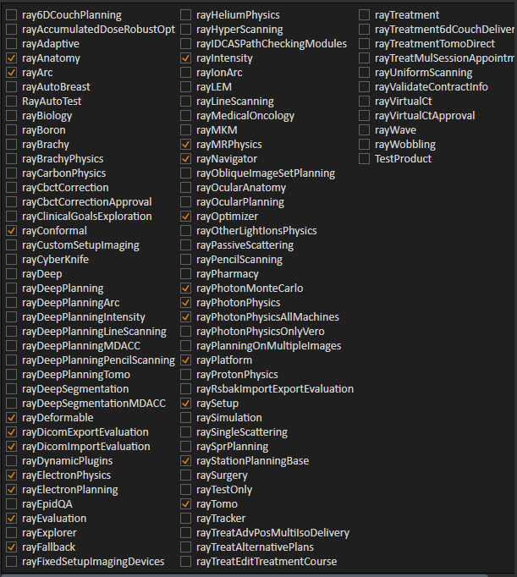

# Radformation

A Radformation sales rep called Sicong last week about Radformation’s two products that work with RayStation: AutoContour and ClearCalc. Sicong told her to contact Dengsong since Sicong has no purchasing responsibility.

# Options Comparison

|  |  |  |  |
| --- | --- | --- | --- |
|  | **MIM** | **RaySearch** | **Radformation** |
| **Price** | See below. | Unknown, but don’t we need to purchase the Tomo license(s) anyway? | Unknown. |
| **Speed** | Very fast because it’s cloud based. | RaySearch does offer cloud hosting for its products, but I think this would require an absolute overhaul of our RayStation installation. Given how slow atlas- and model-based segmentation are in RS, I can’t expect DL to be any faster, but I could be wrong. | Unknown. |
| **OARs/Models** | Includes BrachialPlex and Liver. Does not include Bowel, Stomach, or LNs.  Does not include female pelvis. | Unknown. | Includes BrachialPlex and LNs. |
| **TG-263 Compliant** | Yes! | Unknown. | Yes. |